UserLogin Backend Implementation Complete:

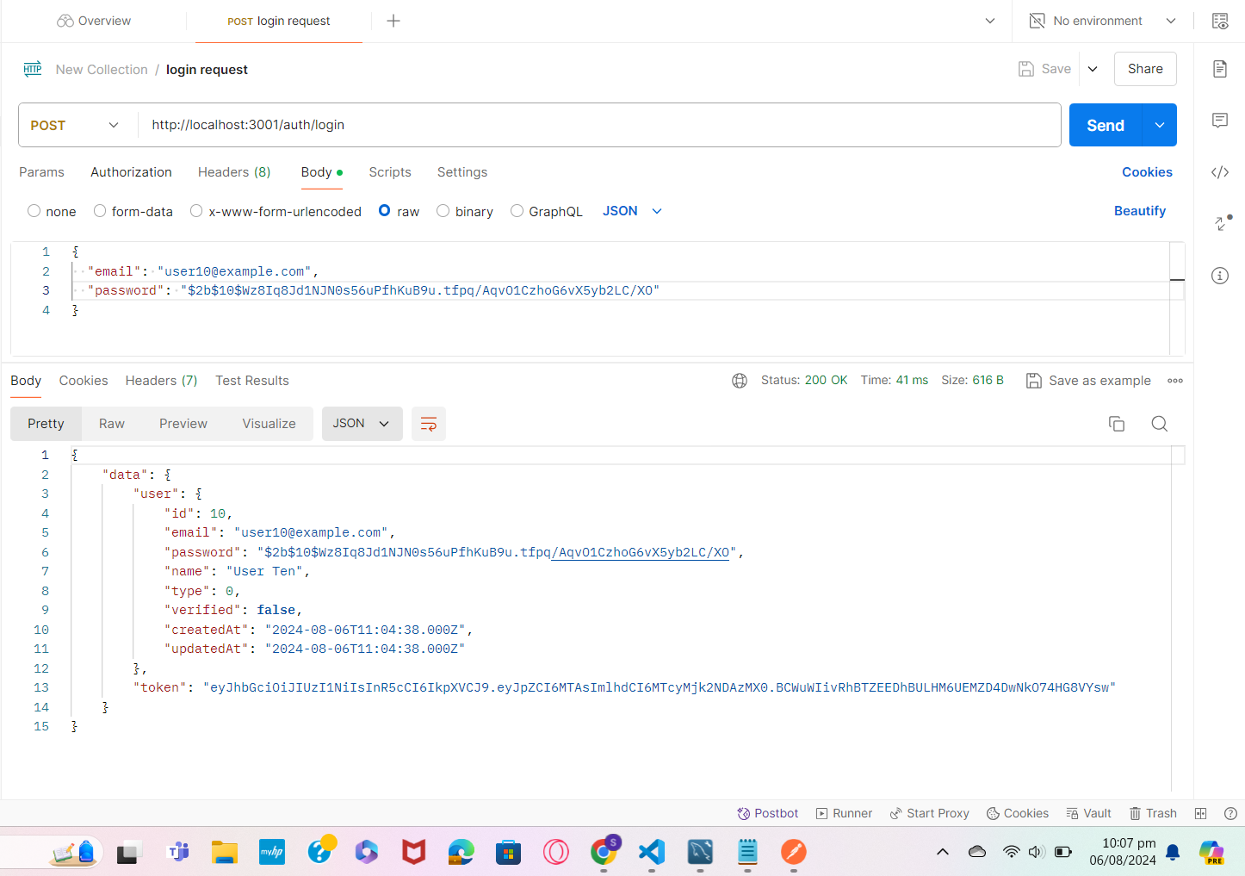

Send grid code: DXCYRCCAXMJRZMV66FT6MJW6